Группа: 16ВП1

Выполнили: Угроватов Д., Лялин Н.

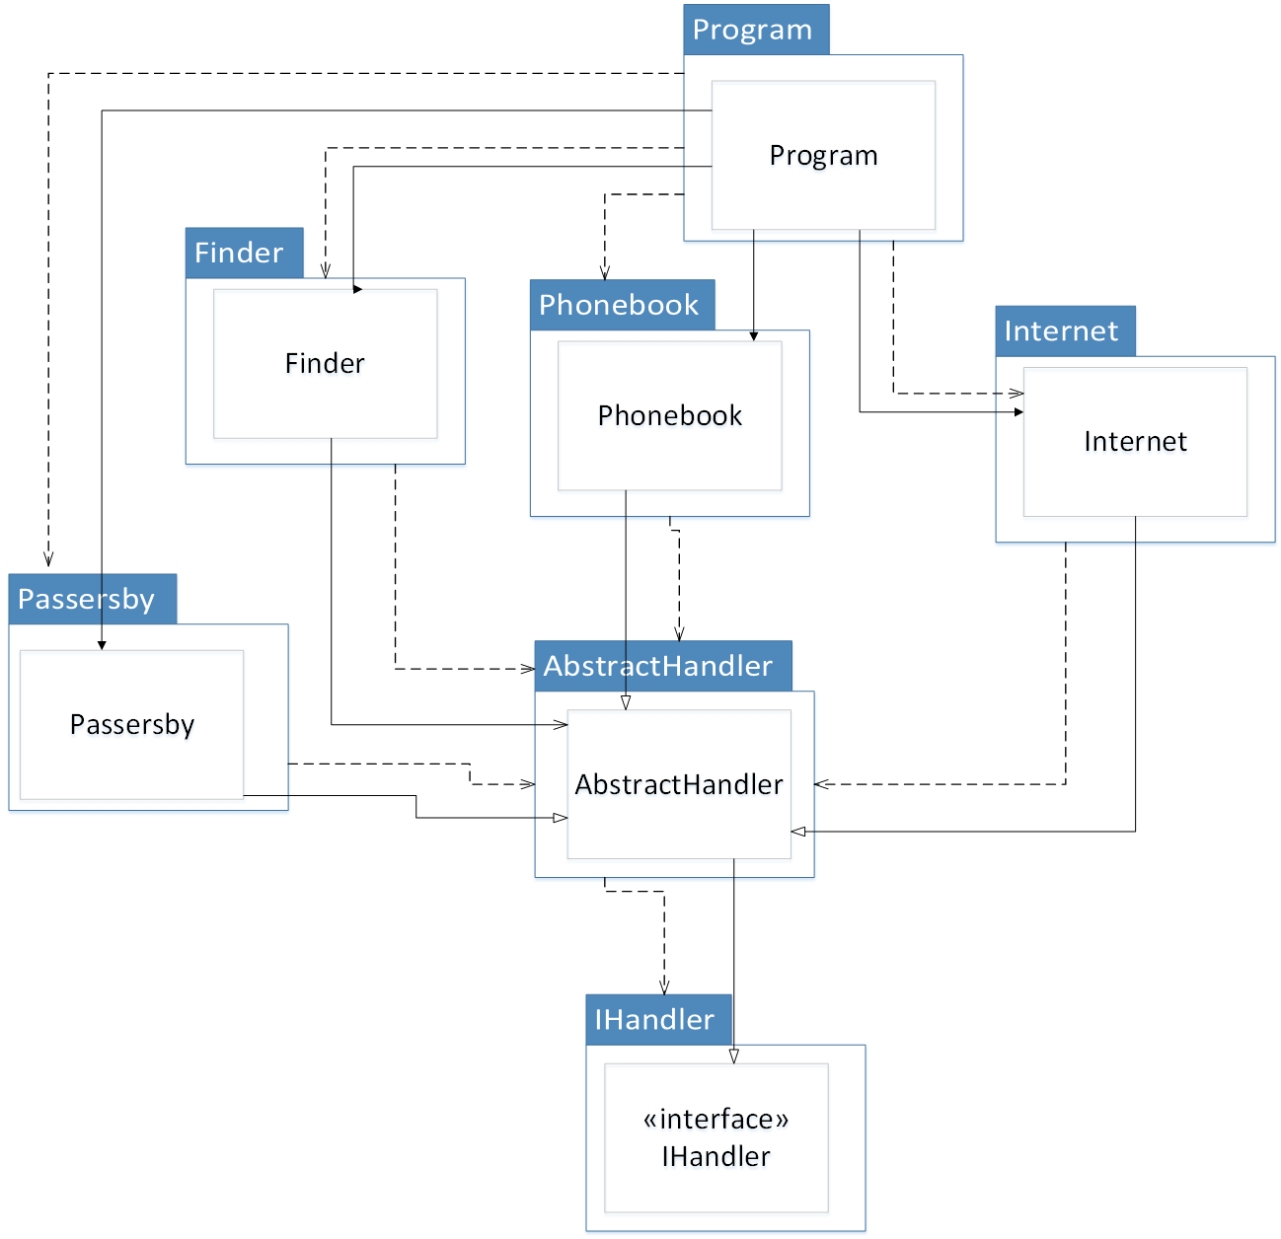

Рисунок 1 - Диаграмма компонентов

Метрики устойчивости

|  |  |  |  |
| --- | --- | --- | --- |
| **Имя компонента** | **Ca** | **Ce** | **I** |
| AbstractHandler | 4 | 1 | 1/5 |
| IHandler | 1 | 0 | 0 |
| Passerby | 1 | 1 | ½ |
| Phonebook | 1 | 1 | ½ |
| Internet | 1 | 1 | ½ |
| Finder | 1 | 1 | ½ |
| Program | 0 | 1 | 1 |

Метрики абстрактности

|  |  |  |  |
| --- | --- | --- | --- |
| **Имя компонента** | **Na** | **Nc** | **A** |
| AbstractHandler | 1 | 1 | 1 |
| IHandler | 0 | 1 | 0 |
| Passerby | 0 | 1 | 0 |
| Phonebook | 0 | 1 | 0 |
| Internet | 0 | 1 | 0 |
| Finder | 0 | 1 | 0 |
| Program | 0 | 1 | 0 |

|  |  |
| --- | --- |
| **Имя компонента** | **D** |
| AbstractHandler | 0.2 |
| IHandler | 1 |
| Passerby | 0.5 |
| Phonebook | 0.5 |
| Internet | 0.5 |
| Finder | 0.5 |
| Program | 0 |